Path Forward Basic Requirements

1. Acceptable test geometry
   1. Traditional 3D Printer: 24 x 20 cm for 3D printer listed below
   2. Kuka arm working envelope

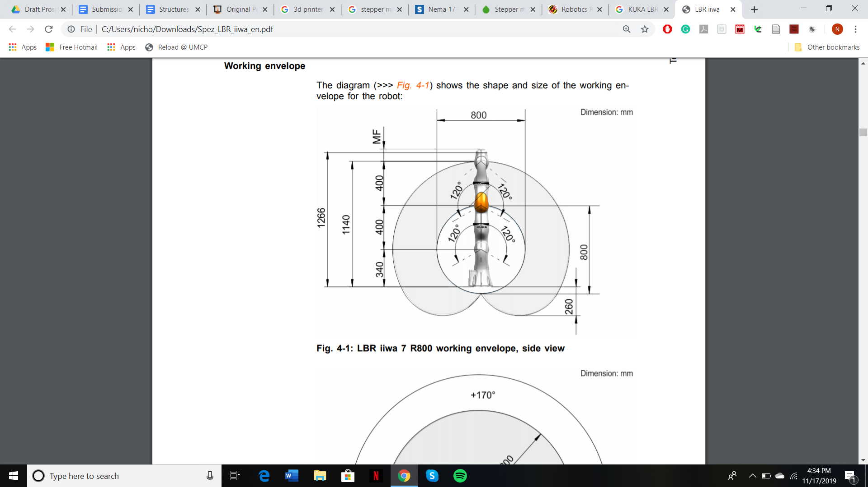

1. What will you be doing next semester?
   1. What must be designed?
      1. 3D Printer Approach
         1. The 3D printing assembly if we are not able to access a robotic arm in CAD
         2. Heating element must be insulated from the motors to prevent melting ambient temperature of the arm should be under 45 degrees c

<https://www.kuka.com/en-us/products/robotics-systems/industrial-robots/lbr-iiwa>

* + - 1. Method of adding additional degrees of freedom
         1. Must not be too heavy
         2. Must not interfere with extruder and be too big to prevent the working envelope from dropping
    1. Robotic Arm
       1. The extruder mount for a robotic arm
          1. What are the requirements of the design?
          2. Needs to fit the dimension that extruder gives and KUKA arm (hole pattern conforms to DIN ISO 9409-1-50-7-M6)
          3. Also needs to be stable and modular
       2. Means of preventing wires from getting tangled
          1. Either up and over the arm to get out of way
          2. Run along arm somehow
          3. Potentially already attached to arm
       3. How to connect power and control systems of arm and extruder
          1. The voltage required for extruder head motors and heating the tip

How is it heated up, will it affect the mount?

* + - 1. Need to feed the material into the extruder and it won’t get tangled
  1. What will you do if you discover a certain design won’t work?
     1. What are your backups?
        1. The backup for the robotic arm is the 3D printer
        2. If there is trouble mounting the extruder on the arm, a custom mount can be 3D printed
  2. We will already have determined our approach by the end of this semester, but will start to buy parts next semester

1. What will you accomplish by the end of the next semester?
   1. We will acquire the parts for our chosen approach
   2. Complete preliminary designs of module mounts (Eg. extruder head, sensors, etc.)
   3. Design CAD assembly of arm (tentative).
   4. Complete precision tests.
   5. Outline void dimension/shape requirements from structures standpoint.
2. What do you want to explore in terms of research?
   1. The use of a robotic arm
   2. Precision of arm at different scales.
   3. Methods of implementing/attaching modules.
   4. Different arm design concepts/examples (pros and cons of each).
3. What resources do you need from Dr. Mitchell?
   * 1. Access to the robotics realization lab
     2. General Finance
     3. Advice from his 3D printing contacts
   1. If you can’t get those resources, what would your budget look like?
      1. Without these resources, we would drop the idea of using a robotic arm and would use a traditional 3D printer and modify it. The printer that the UK researchers used was $750. We would likely have this as the top of our budget for 3D printers and may even get an extremely cheap one at first to experiment with. We would also need the below:

(3D printer) <https://shop.prusa3d.com/en/3d-printers/180-original-prusa-i3-mk3-kit.html?gclid=CjwKCAiA_MPuBRB5EiwAHTTvMS2almvNsqP9G2e5tgvT5ocujOnEJwKntY-EGf8QVw0pFH-K1sCRrxoCsXMQAvD_BwE>

(Duex4 - UK people used this to drive additional stepper motors)

<https://reprap.org/wiki/Duex4>

(stepper motors - 0.9 degree step angle)

[https://www.omc-stepperonline.com/nema-17-stepper-motor/?mfp=149-step-angle[0.9]](https://www.omc-stepperonline.com/nema-17-stepper-motor/?mfp=149-step-angle%5B0.9%5D)

1. What do you need from each subteam?
   * 1. Extruder
        1. Specific dimensions of the extruder head and any sensors that need to be mounted on the arm or the printer
        2. Weight of the extruder to determine the torque requirements if a 3D printer approach is taken
        3. Bowden vs. Direct Drive
        4. Power requirements for extruder
        5. How are you heating the tip
        6. Where is the material going to go?
     2. Scanning
        1. Are we attaching the scanner to the arm, if so where and how heavy?
        2. Power requirements for scanning system
2. What will you bring to the research? In what way is the work or plan novel?
   1. Tests
      1. Testing working envelope of manipulator
         1. Just do it, figure out possible angle at edge of working envelope
      2. Testing precision with the attachment on end
         1. Tell it to move to a certain spot and measure how close it is
         2. Test precision at different speeds - see how much it affects it
         3. Test different kinematic models (no specific one for kuka arm, just use a general one)
      3. Do test prints with extruder on a flat surface
         1. Print a basic shape on a flat surface to test the usage of the full system
      4. Test heating of mount
         1. Use thermometers around key parts of the robotic arm to test ambient heat from the extruder
         2. Do initial testing if extruder subteam isn't ready yet
      5. Test the movement of the manipulated 3D printer head if that method is chosen
         1. Do precise measurements
   2. Verification of prior research models/proposals for future work
      1. Included in testing section above
3. If you discover that your goals or methods are too complicated, what will you do?
   1. Reflect on new information and redesign
   2. Always think of potential problems while we are designing things
4. **In general, if you were to start tomorrow, what needs to happen? Ho w will you make it happen? When are your deadlines?**
   1. We need to decide on our approach and raise money to purchase the materials.

Start preliminary designs of extruder mounts

* 1. CAD work for designs
  2. Buy parts by at least halfway through next semester
  3. Create framework for tests listed above

This is mainly for subteam liaisons:

1. How will you manage your subteam and ensure that your deadlines are met?

High-Level Requirements

# Overall

* Determine the dimensions of the void
* Determine the shape of the void
* Finalize the dimensions and shape after combining findings and requirements of each subteam
* Define autonomy (overall and for your subsystem)
* Plans for independent testing
* Plans for dependent testing
* Determine high level requirements for your own subsystem

# Structures

* Determine dimensions and shape of void (range of measurements)
* Accurate kinematic model of arm
  + Testing accuracy methods
* 3D Model of arm (CAD)
* Electronics requirements
* Budget
* Plans for independent/dependent testing